Essential Tools for Student Productivity

Team Members
1. D. Charishma Lakshmi Durga (TEAM LEADER) Rollno.25A31A0570
2. K. Manoj Rollno.25A31A05AK
3. Ch. Rama Devi Rollno.25A31A0569
4. Ch. Revanth Sai Rollno.25A31A05AE

Guided By
Mr. Y. Manas Kumar
Assistant Professor
CSE Department Pragati Engineering College (A)
Surampalem

Project Description
The Student Productivity Toolkit is a multifunctional console-based application developed using the C programming language.
The main goal of the project is to provide students with a simple, fast, and organized way to manage academic life. The application integrates multiple essential productivity tools into one lightweight program that runs on any computer.
The system allows students to create and manage tasks with deadlines, write and view quick notes with timestamps, log their study sessions, store course grades, and compute their GPA. The project also supports saving and loading data for future use.
Objectives:
- Help students improve productivity through digital task management.
- Provide easy note-taking functionality inside the program.
- Track study sessions for habit building and improvement.
- Record course grades and calculate GPA.
- Save all data so that users can continue where they left off.
- Develop problem-solving, logical thinking, and file-handling skills in C.
Scope of the Project:
The system includes:
- Task Manager (with deadlines + completion tracking)
- Study Session Tracker
- GPA Calculator
- Quick Notes (Add + View)
- Data Storage (Tasks, Courses, Notes, Study Logs)
- Pomodoro Timer Simulation
This project is designed as a beginner–friendly mini project suitable for lab submission, college projects, or basic portfolio building.

System Architecture

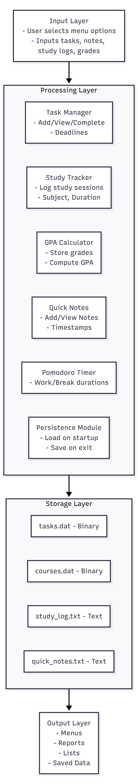

Operational Flowchart

START PROGRAM
↓
Load Saved Data
↓
Display Menu
↓
User Selects an Option
↓

Task Manager Study Tracker GPA Calculator
↓ ↓ ↓
Add / View / Complete Tasks Log Study Time Compute GPA

↓
Quick Notes (Add / View)
↓
Pomodoro Timer (Simulated)
↓
Save Data to Files
↓
Exit or Restart
↓
END

ACKNOWLEDGEMENT
I would like to express my sincere gratitude to everyone who supported me throughout the development of this mini-project titled “Essential Tools for Student Productivity.”
I extend my heartfelt thanks to my faculty/project guide, whose continuous guidance, encouragement, and valuable suggestions helped me successfully complete this work.
I am also thankful to my friends and classmates for their support, feedback, and cooperation during the development process.
Finally, I thank my teammates for their constant motivation and belief in my abilities. This project has helped me greatly improve my understanding of C programming, file handling, modular design, and problem-solving skills.

